The Miami Children’s Initiative is funded by the Ounce of Prevention Florida’s Children’s Initiative Grant.
Miami Children’s Initiative
Summative
Evaluation
Report

Period:
July 1, 2014-July 31, 2015

Cecilia Gutierrez, CEO
Dr. Tisa McGhee, Project Evaluator

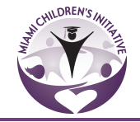

- Executive Summary…………………………………………………………………………………………..3

- Introduction………………………………………………………………………………………………………5

- Description of Programs, Goals and Assumptions…………………………………………..6-8

- Performance Methodology and Data ………………………………………………………….……. 9

- Quality Improvement Plan…………………………………………………………………………….….28

- Recommendations……………………………………………………………………………………….…..29

- APPENDICES……………………………………………………………………………………………..………32

  - Parenting program
  - Photos of Activities

Executive Summary

Miami Children’s Initiative (MCI) is a cradle to career strategy that seeks to facilitate and catalyze effective, sustainable transformation in Liberty City.

This summative evaluation reviews the progress of the implementation based on data compiled through July 31, 2015. The report is intended to provide cumulative information for the final outcome evaluation. We will focus on the three program areas we proposed the Block-by-Block, Peacemaker Program and SMART or School Readiness Programs.

What we learned…year end performance increases

Block-by-Block -
- 96% of children under 5 yo are enrolled in a quality school readiness program
- 95% of 40 school aged children received age appropriate tutoring
- 75% of children in the impact zone are receiving and enrichment experience
- 91% of every school aged children is enrolled in a summer program

Peacemaker Program - Safety and Anti-Violence Efforts:
- 95% residents receiving employment and training
- 57 youth receiving employment training and paid summer internships.

SMART: School Readiness & Education/Parenting:
- 89% overall average attendance rate for children ages zero to five.
- Over 40 training opportunities, attended by 75 ELCs in the Liberty City area, training evaluations indicated a satisfaction average of 4.8 of 5
- 95 parents participating in opportunities to learn and grow as advocates and champions for their children and community through parenting classes.

Implications
Data will be used to track future credentialing, attendance, and performance for their providers and the children and families they serve. Student and Family Advocates will have access to, and responsibility for, the files of the children to which they have been assigned.

Challenges
- Data collection from collaterals (MDCPS), and resource referrals
- Attendance has a direct impact on the student’s grades and efforts at school
- Analysis was difficult due to several variables noted

Recommendations

Sharing the recent research with the MCI Student and Family Advocates may also help to increase their ability to understand the importance of school readiness education, and consequently, the value of the extraordinary tasks that they must perform to help parents and their children every day.

As with most non-profits, MCI may benefit from the development of a stronger cadre of professional and trained volunteers along with their current volunteer and paid staff. This will not only reduce the workload of the existing employees and volunteers, it can aid in upgrading the skill level of the entry-level workers by giving them access to the information and resources of trained professionals.

Finally, MCI may benefit from having a better communication system that includes e-mails, telephone calls, and the web site along with a messaging board that is visible to residents in the community and updated on a regular basis. This outreach method might help to peak the interest and involvement of families who have not been as active in several programming efforts, and which may prove to be a gateway to further participation in MCI’s myriad strategies for community improvement.

Introduction

Overview and Philosophy: Miami Children’s Initiative (MCI) is a cradle to career strategy that seeks to facilitate and catalyze effective, sustainable transformation in Liberty City. MCI’s mission is to create a community-based network that develops, coordinates, and provides:

- Quality education
- Accessible health care
- Youth development programs
- Opportunities for employment
- Safe neighborhoods for children and families residing in Liberty City.

MCI works to ensure babies are born healthy, are thriving by age three, are ready for school by age five, are reading at grade level by third grade, are succeeding in school, are graduating from high school, are prepared to enter and complete college, and begin their careers and give back to their community.

Behind this mission lie two main tenets rooted in the Harlem Children’s Zone model that MCI has full embraced as it implements the cradle-to-career strategy in Liberty City:

First, a critical mass of adults, who are well versed in the techniques of effective parenting, and are engaged in community come together to develop local educational, social, and religious activities with their children in order to ensure that they are growing into healthy and satisfying adulthood.

Second, the earlier a child is touched by sound health care, intellectual and social stimulation, and consistent guidance from loving, attentive adults, the more likely that child will be to grow into a responsible and fulfilled member of the community.

This summative evaluation reviews the progress of the implementation based on data compiled through July 31, 2015. The report is intended to provide cumulative information for the final outcome evaluation. We will focus on the three program areas we proposed the Block-by-Block, Peacemaker Program and SMART or School Readiness Programs. We examine data collected throughout the 2014-2015 evaluation period and discuss how the data provides evidence of our successes and challenges with this work. We close with a description of implications of the data analysis and some recommendations for the continued work.

Description of Programs, Goals and Assumptions

Program Operation: Synopsis of current activities and services being provided to the targeted population at each site;

The primary programs offered: 1) Block-by-Block: School and Neighborhood-Based Academic/Enrichment Support to Improve School Outcomes; 2) Peacemaker Program to Prevent Crime and Build Career Success; and 3) SMART/School Readiness A Focus on Young Children and Their Families.

Block-by-Block participants must live in Liberty City, reside on eight blocks (from NW 59th Street to NW 62nd between 17th Avenue and 20th Avenue) and be 24 years old or younger. The MCI’s Florida Children’s Initiative program (MCI-FCI) provided academic support program to Liberty City elementary, middle, high school and post-secondary participants and their families at their schools and partner sites throughout the neighborhood, including small group tutoring; cultural, educational and historical enrichment activities; access to computers, internet, school supplies, and homework help; and intensive academic case management, utilizing a family and child specific intervention plan.

Initially a comprehensive resident home survey/assessment were completed on every child and their family served. The assessment collected data on family employment and income, residential history, internet access, transportation, health and wellness, household needs and resources/assets, current and/or desired services and supports, and child specific information on every child, regarding: health, early care and education, mentoring, tutoring, enrichment and sports, cultural, and/or other activities. For each child, parents were asked to state their vision, hopes and aspirations. From this data, a family and child specific intervention plan was developed with each family. Connection and collaboration with MCI’s extensive network of services begins on behalf of every family member. After the goals are set, MCI’s student and family advocates work with the children and their families towards accomplishing the goals in their specific plan.

The agreed upon family plan was used to monitor progress and commitments made by the Family and MCI. Currently, MCI is updating the process for assessment and continued monitoring.

For Children and Youth, MCI’s Block-by-Block Strategy is built on the following outcomes:
1. Every child under the age of five is in a quality School Readiness Program;
2. Every school aged child receives appropriate tutoring;
3. Every school aged child is in an after-school program;
4. Every child is receiving an enrichment experience (music, art, karate, tennis, dance, etc.);
5. Every school aged child is in a summer program;
6. Every child has a medical home and is current on key Early and Periodic Screenings, Diagnostics and corresponding Treatment (EPSDT).

For Parents/Caregivers, MCI’s Block-by-Block Strategy is built on the following outcomes:
1. Linkages to immediate services and needs (based on the family plan);
2. Invest in families by offering opportunities to learn and grow as advocates and champions for their children and community (Parent classes);
3. Workshops on topics such as stages of development, discipline, bonding, safety, health and nutrition;
4. Counseling services and referrals to services based on need;
5. Financial literacy and skill building opportunities;
6. Employment and training;
7. A medical home.

Peacemaker Program - Safety and Anti-Violence Efforts: We have committed to greatly reducing and to ultimately minimizing the violence that has infected our streets and homes in Liberty City. To this end we have implemented the critically acclaimed Peacemaker Program in Liberty City. The presence of the Peacemakers on the streets will continue as an organized deterrent to crime. Peace Service Workers will be recruited from the residents of the area. All activities will take place within the Impact Zone (8-blocks) and locations will include the MCI Community Space.
SMART: School Readiness & Education/Parenting: We are committed to lifting the quality of Early childhood and Education in Liberty City through the development of a Shared Services Network for the Early childhood and Centers that serve our children, linking centers to the Star Quality Rating and Improvement System, and adding a Curriculum Specialist to help centers get our kids “school ready”. In addition, we’ve added two additional programs to ensure that parents get the skills and education they need to know why this is so important. These research-based, proven, 5-12 week programs are:

- Baby and Me: 10-week program
- Strengthening Families: 12-week program
- The Baby Arts Program: 5-week program
- The Children’s Trust Community Parenting Engagement Program: 8-week program
- Self Improvement Class: 14 sessions
- Sister Friend Class: 10-week program

In partnership with the University of Miami, MCI implemented two cohorts of the Baby & Me Parenting Group. A ten-week program for parents and their babies, ages birth to 12 months. Parents attend with their babies to discuss topics such as attachment, development, nutrition, sleep, and behavior. Families receive free items such as blankets, rattles, and other toys related to the topics discussed and create a scrapbook for their babies. Daytime and evening groups were offered on a weekly basis in English and Spanish to Miami-Dade County residents at various locations throughout the county.

MCI also implemented two cohorts of The Strengthening Multi-Ethnic Families & Communities Parenting Group, a twelve-week program for parents and caregivers of children ages 1 to 5 years. Group members discussed ways to manage behavior, teach children problem solving skills, and help them identify and express their feelings appropriately. Families learned ways to build stronger families while helping their children develop. Parents received topic related items. Daytime and evening groups were offered on a weekly basis in English and Spanish to Miami-Dade County residents at various locations throughout the county.

In partnership with Arts for Learning (A4L), MCI implemented the Baby Artsplay! Program. The goal of Baby Artsplay! is to provide a holistic music, movement, and drama program to support the very young child’s social, emotional, intellectual and motor development through quality arts interactions with adults. Parents and their children will participate in 5 weekly sessions.

In partnership with the Children’s Trust the Community Parenting Engagement program was initiated with one cohort starting in February 2015. This parenting program was co-led and facilitated by two parents sharing a culturally specific curriculum. The parent group met once a week from 5:45 to 8 p.m. for eight weeks. They met, talked and shared dinner together as described in the spotlight found in the appendices.

The Sister Friend program is a parenting intervention for women that follows tried and tested interventions such as (SISTA, Effective Black Parenting) that addresses ethnic and gender pride, health and sexual wellness, Assertive and Communication skills, Healthy Relationships, Equality, Advocacy and Coping skills. The intervention consists of 4-12 consecutive 1 to 4 hour sessions that are incentive based and participant interactive.

Performance Measures and Data

Program Evaluation Methodology

A mixed method research design of quantitative and qualitative measures were used to answer the questions related to the project goals and to assess outcomes. This design was selected because it offers the most powerful evaluation of the project, addressing concerns about validity and reliability and thus the transferability of the findings to other settings (Frechtling & Sharp, 1997).

Stufflebeam’s context, input, process, and products (CIPP) model will provide a framework for the evaluation. It provides a robust tool for continuous quality improvement activities to identify performance measures and ensure outcomes for students. Fundamentally, the model promotes growth and assists leaders and project staff to obtain and use feedback systematically to meet important needs and adhere to grantor guidelines (Stufflebeam, Madaus, and Kellaghan, 2000.) The model provides a comprehensive framework for the development of evaluation questions. The CIPP framework addresses project issues related to progress (formative) or achievement (summative) goals and objectives.

Barry University created, complied and conducted surveys (quantitative), as well as on-site program visits (including qualitative interviews) to monitor and to track progress toward program goals and objectives. The evaluation team consisting of Dr. Tisa McGhee, two doctoral students and a MSW student prepared a formative summary (February 2015) to include analysis of program operation, objective assessment, participant interviews and surveys, and recommendations for improvement. This summative evaluation is being prepared as required (July 2015).

Miami Children’s Initiative places high priority on evaluation, accountability, data-driven decision-making, and informing the field in order to lift up evidence-based practice at the state and national levels. MCI has broad experience obtaining, managing, analyzing and reporting data from program staff, sub-contracted partner organizations, and obtaining participant academic from Miami Dade County Public Schools. The data compiled, analyzed and reported for Miami Children’s Initiative is comprehensive, covering not only the number/demographics of youth served but also dates of service, service types, dosage, and academic outcomes at the individual participant level.

Demographics:

Youth Served | Mid Year (201) | End Year (191)
Gender | Male 46%  Female 54% | Male 49%  Female 51%
Age | 0-5 35%  6-18 60%  19-24 5% | 0-5 35%  6-18 64%  19-24 1%
Grade in School | 1st 17  2nd 11  3rd 17  4th 11  5th 9  6th 10  7th 9  8th 6  9th 12  10th 9  11th 5  12th 4 | 1st 18  2nd 10  3rd 16  4th 10  5th 9  6th 12  7th 5  8th 8  9th 8  10th 9  11th 4  12th 1

Total number of Youth Served: The total number of youth served decreased by 10 due to recidivism issues (parent no longer wanted to participate in programming, lack of active engagement even after supportive encouragement, youth in protective care or family moved out of area). MCI is actively recruiting youth and families in the block-by-block programming to replace and retain those already involved in programming. In fact, MCI has provided ancillary services and referrals to more than 450 youth and families in the area. New participant counts appear to fluctuate and vary, however this report will concentrate on the 191 participants that were tracked in the initial report made.

Gender: From the last report the gender of youth participants shifted slightly to reflect an increase in the males served from 46% to 49% and as a result the female participants decreased from 54% to 51%.

Age: Our population of youth 0-5 remained the same while there was a 4% increase in the 6-18 population and decrease in the 19-24 populations.

Objectives:

Table 1: 2014/2015 Summative Data

Desired  Outcome | Data Point | Target | Mid Year Performance | End Year  Performance
Every child under the age of five is in a quality School Readiness Program | Percent of enrollment in School Readiness | 100% | 80% | 96%
Every (40) school aged child receives appropriate tutoring | Percent of enrollment in tutoring | 100% | 82% | 95%
Every school aged child is in an after-school program | Percent of enrollment in after-school programs | 100% | 60% | 40%
Every child is receiving an enrichment experience (music, art, karate, tennis, dance, etc.) | Percent of enrollment in enrichment experience | 100% | 60% | 75%
Every school aged child is in a summer program | Percent of enrollment in summer programs | 100% | 50% | 91%
Every child has a medical home and is current on key Early and Periodic Screenings, Diagnostics and corresponding Treatment (EPSDT) | Enrollment in a medical home | 100% | No data previously reported. | 20% of 10 parents

Parents/Caregivers Desired Program Outcomes

Desired Outcomes | Data Point | Target | Performance
Linkages to immediate services and needs (based on the family plan) & | Percent of linkages made | 80% | 40%
Invest in families by offering opportunities to learn and grow as advocates and champions for their children and community | Percent of enrollment and completion of parenting classes | 100%  of 90 parents | 105%  95  parents
Workshops on topics such as stages of development, discipline, bonding, safety, health and nutrition; | Percent of workshops/activities attended by parents | 100% of  40  parents | 37%  15  parents
Counseling services and referrals to services based on need | Percent of counseling linkages made | 50%  100  referrals for need  .03%  Received referred services total 30 | 100%  207 referrals for need  12%  Received referred services  total 32
Financial literacy and skill building opportunities | Percent of workshops/activities attended by parents | 100% of  40 parents | 10%
Employment and training | Percent of workshops/activities attended by parents | 100% of  40 parents | 95%
A medical home | Percent of families with a medical home | N/A | 20%
Reduce the # of criminal activities in the Impact Zone – | Review crime statistics for Liberty City Impact Zone | 50% reduction | 10%

Program Performance Overview

Every child under the age of five is in a quality school readiness program

MCI is committed to ensuring that children in the Impact Zone receive school readiness services. To this end, a goal of enrolling all of the children ages zero to five in a qualified, well-performing School Readiness (ELC) is a priority.

School Readiness Center Student Enrollment
The total capacity of the 35 open ELCs is approaching 1,900. In order for MCI to reach its goal of enrolling 100% of the children ages zero to five in an ELC, the MCI staff met with the ELCs to request that slots be prioritized for MCI Impact Zone children. This agreement allowed MCI to refer and assist with the enrollment of 96% of its target population.

Attendance

The families with children ages zero to five who are enrolled in Voluntary Pre-Kindergarten (VPK), Pre-Kindergarten (Pre-K), or Kindergarten (K) classes may face challenges such as not having enough money to pay for child care, difficulty maintaining reliable transportation to get them to the ELC, and insufficient parenting skills and resources. MCI’s Advocates work with these parents to ensure that their eligible children attend the early education Centers more often than they are absent. A few of the families have moved or withdrawn from the program (due to non-participation), but the majority of the parents are working cooperatively with MCI to ensure that their children receive the early learning opportunities that will help them be on par for starting school eager and ready to learn.

As a result of this concerted effort, MCI has enrolled 57 of its Impact Zone children and 30 additional children who live in Liberty City but do not reside in the Impact Zone in the Summer Early Learning Clinic. The MCI Child Advocates continue to monitor the children’s attendance and to encourage the parents, equipping them with the skills and resources to help increase their children’s attendance and performance in the ELCs.

During the 2014/2015 school year (August through June) there was an 89% overall average attendance rate for children ages zero to five (VPK, Pre-K and K) who reside in the Impact Zone and were enrolled in its ELCs. The analysis of these attendance data considered the number of days absent, excused and unexcused absences, factored into the total number of days of instruction. The average attendance rate for K students was 88.7 days.

These analyses show a fairly consistent monthly attendance rate, with several students having higher rates of absenteeism (one Pre-K student had a 19 days of unexcused absences while another had 20 days of excused absences). Similarly, there were two K students who each missed 35 days of instruction, while the majority of students had only a handful of excused and unexcused absences. When these outliers are removed from the analyses, the data show at least a 91% attendance rate.

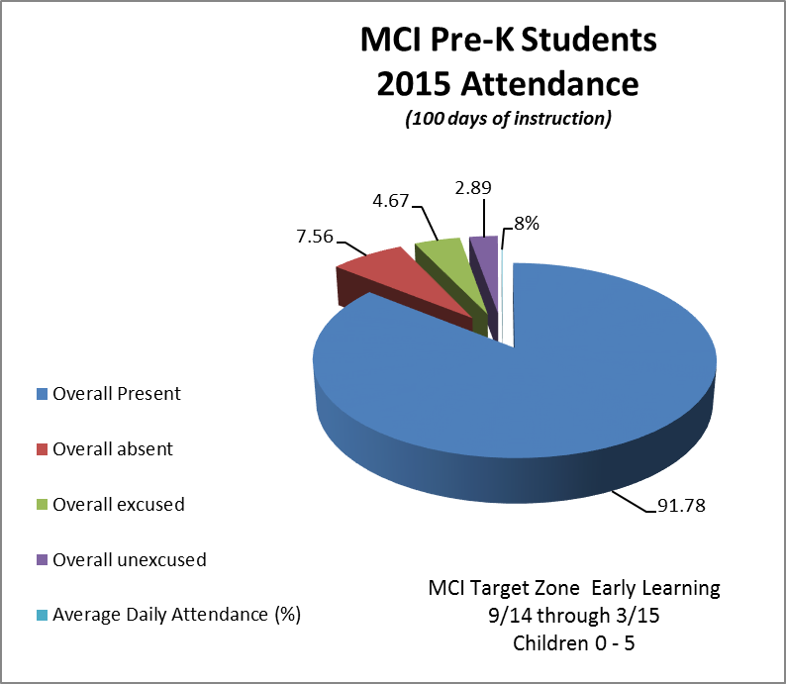

Performance

Fifty-seven children between the ages of three and five, who were enrolled in MCI’s Summer Learning Clinic were administered the B.E.L.L. Assessment Test to determine their readiness for kindergarten (See BELL Assessment Scores). The MCI’s School Readiness directors administered the battery for a baseline analysis. Students were assessed for school-readiness in the areas of Word Awareness, Rhyming Words, Segmenting, Concepts of Print, Letter Identification, Alliteration, and Blending. The overall performance for the eleven three-year-olds showed that most were below expectations (See BELL Assessment Scores). Additionally, for the 30 four-year-olds, while there were some whose skills were below expected, a greater number either met or exceeded expectations (See BELL Assessment Scores). Finally, the assessments for the 16 five-year-olds showed most students performing below or at the expected school-readiness levels.

The initial data provided a starting point for future assessments and a way for the MCI staff to measure future progress and to develop appropriate strategies to improve areas where preschoolers are not prepared for, and excited about, learning in the school system.

B.E.L.L. Project Scores

Groups | Word  Awareness | Rhyming  Words | Segmenting | Concepts of Print | Letter  Identification | Alliteration | Blending
Group 1  n=11  3 Year olds | BE =8 | BE =11 | BE =7  EE=4 | BE=11 | Not assessed | BE=11 | BE=7  EE=4
Group 2  n=30  4 years old | BE=16  ME = 3  EE=11 | BE=22  ME=5  EE=6 | BE=3  ME=5  EE=22 | BE-27  ME=0  EE=5 | BE=17  ME=1  EE=12 | BE=14  ME=4  EE=7 | BE=8  ME=2  EE=20
Group 3  n= 16  5 years old | BE=12  ME=1  EE=3 | BE=14  ME=1 | BE=9  EE=7 | BE=16 | BE=14  ME=2 | BE=14  BE=2 | BE=8  ME=1  EE=7
Key BE= Below Expectation ME= Met Expectation EE= Exceeded Expectation

Following the assessment the meaning of the results were shared with individual parents and parents were advised of strategies to assist the children with further development of their children during the summer learning clinic period.

Youth 6-18 years old

The total number of youth 6-18 years old within the block-by-block program is 124. We tracked this population for school grades and attendance, tutoring, enrichment experiences, and summer program participation.

School Grades & Attendance Data
Based on data collected for 113 of the 124 youth the overall mean GPA was 2.3 in both the 2nd quarter (quarters 1 & 2 combined) and the end of the year (quarters 3 & 4). There was a minor decrease (-.1) for elementary students mean GPAs and a increases for both middle and high school mean GPAs.

Attendance is an area for continued monitoring and engagement of families in the importance of attending school and being on time for school. The data revealed the mean absent days increased from 5 to almost 8 days, with the number of students with absences of 4 to 5 days doubling from mid year (42) to end of year (83). After engagement tardies did drop from 42 to 4 at the end of the year.

Behavioral referrals also require significant support as mid year in school and out –of-school suspensions rose at a noteworthy rate. See chart below.

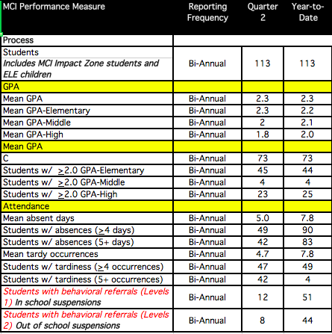

Every school-aged child receives appropriate tutoring

MCI initially intended for every school aged child to receive tutoring, however resources were limited to serving 40 of the youth with the highest need for academic tutoring support. Participation in tutoring occurred 3-5 days per week from 1-3 hours during those days. Parents continue to see this as a valuable asset.
Statements from parents indicate that participating youth’s grades are improving due to tutoring.

More than half of the 60 youth surveyed were happy or very happy participating in tutoring. Thirty-seven percent reported they did not participate in tutoring.

Every school-aged child is in an after-school program

Data from community funders reveal Liberty City programs were allotted afterschool funding for 545 children and youth; this represents coverage for merely 10% of the target area’s school age population. One provider available to facilitate afterschool services at the K-8 Center in the Impact Zone; indicated their service model and funding do not extend to students in elementary grade levels, leaving a crucial gap in services.

MCI plans to implement an afterschool program in 2015-16 school-year, utilizing 21st Century funding. Of the 57 youth surveyed about their after school program experience 24 indicated that they were happy or very happy to participate.

Every child is receiving an enrichment experience (music, art, karate, tennis, dance, etc.)

Enrichment experiences referred/offered by MCI include: Sports programming, the Excel program, Miami Music Project, Bike Sharing program, U Fit Gym, and the Liberty City Opera program.

Four activities were assessed for satisfaction around engagement. Results revealed that activities like having a computer lab at the MCI Community Space, Christmas in July event, Community Beautification efforts and field trips were among the highest rated by the student as responding happy or very happy.

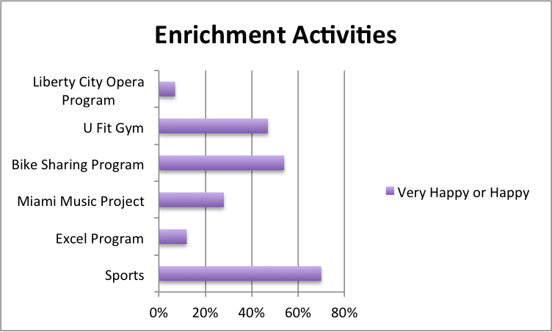

Seventy-five percent of the total youth population served by MCI is participating in some type of enrichment activity. A sample of 60 youth surveyed indicated they were involved with several enrichment activities offered by MCI. Seventy percent were happy or very happy participating in sports (football, basketball, track and skateboarding). Another 54% enjoy the bike-sharing program along with 47% being happy or very happy participating in the U Fit Gym. Smaller percentages were involved with the Miami Music Project (28%), the Excel Program (12%) and

Every school aged child is in a summer program

During the summer of 2014 a total of 60 youth participated in a summer program with MCI partner organizations, the African Heritage Cultural Arts Center and Miami Dade Parks and recreation summer programs, 5 days a week for 10 weeks. In the summer 2015, MCI created many more opportunities for summer programming for youth 3-18. Fifty-seven (three, four and five year olds) participated in a summer learning clinic, 207 (6-18 year olds) registered for summer camps and a total of 113 participated in summer camp opportunities including 46 youth who received employment training and internships. Twenty-one youth participated in the One United Mural Project as a part of their summer experience.
Thirty-eight of the 59 youth surveyed were happy or very happy with their summer camp experience. Some of the 2105 opportunities for summer programming with partner agencies included: African Heritage Cultural Arts Center, Summer by the Sea program, YMCA Marine Biology program and the Miami Children’s Museum.

Every child has a medical home and is current on key Early and Periodic Screenings, Diagnostics and corresponding Treatment (EPSDT)

Data from a sample of 10 Impact Zone families revealed that 100% of them have health insurance, with 90% having had health coverage over the past year. Ninety percent asserted they did not have difficulty accessing health care in the past year; found inconvenient hours did not prevent them from receiving health care in the past year; nor did costs prevent them from going to the doctor or getting prescriptions. One hundred percent indicated they and their children had a check up in the last year. Only 20% reported having had 2 or more visits to the emergency room in the past year.

However a low percentage (20%) of these same families claimed to have knowledge of being enrolled in a medical home. Approximately half of the parents surveyed we not sure if they were enrolled, although the parents with knowledge of enrollment stated they had increased quality and accessibility of health services.

MCI plans to focus attention to ensuring more parents are aware of their medical home placements and when and where to make sure their children are receiving key early and periodic screenings, diagnostics and corresponding treatments. With focused attention in this area there would be an increase in medical home participation and parental knowledge.

SMART: School Readiness/Parenting: development of School Readiness in the Impact Zone

It was discovered that area School Readiness (ELCs) were in need of capacity building services to improve the quality of care for children under five. Prior to MCI’s commitment to help train and professionalize these early childhood education agencies, very few, if any, of the ELCs or their administrators and staff had attended trainings in the operation, licensing, or credentialing necessary to be considered a quality child care provider.

MCI’s Early Learning Administrators, Dr. MaryAnn Lesser, and Terry Rutherford, developed, facilitated, and continue to provide ongoing professional development workshops for ELCs, their leaders, and workers. MCI also partnered with United Way and many licensed clinicians and trainers to provide ongoing training, certification and performance monitoring. By 2015 there were 35 open and three closed ELCs in the MCI Impact Zone.

School Readiness Training
MCI staff has developed, facilitated, and coordinated over forty training opportunities, which have been attended by 75 ELCs in the Liberty City area, including the 35 located in the Impact Zone. Many of the training sessions included a workshop evaluation with suggestions for future training. These evaluations showed a satisfaction average of 4.8 of 5, often accompanied with compliments, appreciation, and excitement in response to the information provided during the workshops. Some of the workshop titles included the ones listed below along with many others:
- Standards For Four-Year-Olds
- VPK Assessment Instructional Implications
- How to Administer the Florida VPK Assessment
- VPK Assessment Instructional Implications
- DCF Rules & Regulations
- CPR/First Aid
- Defining Liberty City Early Care & Education
- Overview of Creative Curriculum for Infants & Toddlers
- The Affordable Care Act
- Lunch & Learn Sessions (A Variety of Topics)

School Readiness Credentialing

Of the 35 operational ELCS, 27 are licensed, 17 have contracts with the Department of Children and Families (DCF), ten have achieved Quality Counts recognition, two are pending Quality Counts recognition, one has received a three-star rating and one has achieved a two-star rating. All 35 of the ELCs have participated in the ongoing workshops (see ELC Training Report) with most ensuring that three or more of their staff attended each workshop.

Parents are attending a parenting class – parenting class enrollment

Parenting Class | Mid Year | End Year | Total
Baby and Me | 3 | 5 | 8
Strengthening Families | 16 | 13 | 29
The Baby Arts Program | 11 | 13 | 24
TCT Parenting Program | 11 | 15 | 26
Sister Friend | N/A | 12 | 12
TOTAL |  |  | 99
Baby & Me Parenting Group. A ten-week program for parents and their babies, ages birth to 12 months. A total of 8 parents were served through this program. Forty-six percent of parents were satisfied or very satisfied with the program.

Strengthening Multi-Ethnic Families & Communities Parenting Group, a twelve-week program for parents and caregivers of children ages 1 to 5 years. A total of two cohorts with a total of 29 parents were served through this program. A satisfaction survey revealed more than half of 69 parents were satisfied or very satisfied with the program.

The Baby ArtsPlay! Family Program served 24 parents, mostly moms, and 30 infants and toddlers at the satellite office. Through the Family Program, parents have built up the confidence to ask questions about their child’s care and development and have learned to let down their guard to actively play, move, dance and sing with their children. Many of the parents expressed this was not happening before this program with any kind of intentionally as to how dramatic play would benefit their child/ren development. Thirty-eight percent were satisfied or very satisfied with the program.

The Children’s Trust the Community Parenting Engagement program was initiated with one cohort starting in February 2015. A total of 11 parents were served in group one and 15 parents in group 2 as a part of this program and have continued to engage as a group even after completing the program. Forty percent of parents were satisfied or very satisfied with the program.

The Sister Friend program is a parenting intervention for women that follows tried and tested interventions such as (SISTA, Effective Black Parenting. Twelve parents participated in this first cohort of this group started in May 2015. Of the parents surveyed 36% were satisfied or very satisfied with the program.

A self-report survey of 69 parents were used to produce the results of satisfaction referred to above. In most instances there were 32-40 parents who did not participate in parenting programs. A total of 95 parents participated in a parenting programs with a referral from MCI.

Reduce the # of criminal activities in the Impact Zone – crime statistics for Liberty City

Liberty City’s crime index reveals the areas considerable vulnerability in regards to health and safety. On a scale comprised of geo-mapped Uniform Crime Report (UCR) data from neighborhoods across the U.S., Liberty City ranked three on a scale of 1-100, with 100 being the safest. In the Liberty City area, violent crimes account for 44.25% of all crimes. The violent crime rate is 108.16 crimes per 1,000 residents. As a resident of Liberty City, the likelihood of becoming a victim of violent crime is 1 in 23, almost double the likelihood in the larger City of Miami.

Criminal Activity | Mid Year
Aggravated assault/battery | 27
Armed robbery | 7
Arson | 0
Att. Murder Manslaughter Murder Manslaughter | 0  0
* Data from Miami-Dade County Juvenile Services Department

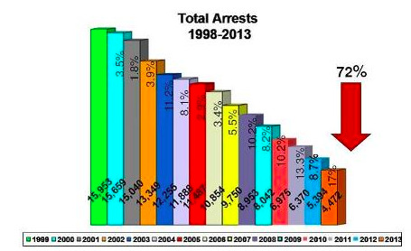

The trend from 1998 to present has been a steady decrease in the total arrests for Miami-Dade County overall.

Safety Survey data

Heighten sense of safety is felt by children and families residing in the Impact Zone (With specific concentration in nine blocks)

Safety continues to be a significant issue in the Impact Zone. However, MCI appears to be making some strides in reducing the amount of criminal activity in the Impact Zone as share through antidotal data from community members. The end of year survey of a sample of families also indicates an increase in areas of social cohesion, perceptions of the environment and the community.

A sample of the data has revealed the following about Neighborhood Social Cohesion:
Neighborhood Social Cohesion | Mid Year (30) | End Year (10)
In a typical week, how many times do you visit with people in this neighborhood? | 55% replied more than 4 times | 40% replied all the time
How much do you trust your neighbors? | 27% Slightly trust  34% Somewhat trust | 40% Trust  30% Somewhat trust
If a neighbor needed help, how likely would you be to offer assistance? | 41% Quite likely | 60% Quite Likely

Perceptions of the environment exposed the following responses:
Perceptions of Environment | Mid Year (30) | End Year (10)
There is a lot of graffiti in my neighborhood. | 41% Neither agree or disagree | 50% strongly disagree
Vandalism is common in my neighborhood. | 24% Neither agree or disagree  24% Somewhat agree | 50% strongly disagree  20% Somewhat disagree
There are too many young people hanging out on the streets near my home. | 30% Agree  27% Strongly agree | 40% Somewhat disagree  30% strongly agree
I fear becoming a victim of crime in my neighborhood. | 33% Strongly agree | 30% Strongly agree
The police protection in my neighborhood is adequate. | 28% Neither agree or disagree | 10% Neither agree or disagree
My neighborhood is safe. | 28% Somewhat disagree  14% Strongly disagree | 20% strongly disagree  40% somewhat agree

Perceptions of the environment has made significant strides with between 60-70% of the sample indicating they agree or strongly agree their neighborhood is clean and people in their neighborhood are taking good care of their homes and apartments. Also a note worthy change is that 100% strongly agree or somewhat agree that they feel safe walking in my neighborhood during the daytime.

When asked to think about the people in your neighborhood and indicate how much each situation is likely or unlikely community members provided the following responses:

Neighborhood Community | Mid Year (30) | End Year (10)
If a group of neighborhood children were skipping school and hanging out on a street corner, how likely is it that your neighbors would do something about it? | 30% Somewhat likely  27% Neither likely nor unlikely | 30% Very likely 50% Somewhat likely
If a child was showing disrespect to an adult, how likely is it that people in your neighborhood would scold that child? | 43% Somewhat likely  20% Neither likely nor unlikely | 50% Very likely  40% Somewhat likely
If there was a fight in front of your house and someone was being beaten or threatened, how likely is it that your neighbors would break it up? | 40% Somewhat likely  20% Neither likely nor unlikely | 50% Very likely  30% Somewhat likely
Suppose that because of budget cuts the fire station closest to your home was going to be closed down by the city. How likely is it that neighborhood residents would organize to try to do something to keep the fire station open? | 23% Somewhat likely  27% Neither likely nor unlikely | 40% Very likely  10% Somewhat likely

There are differences suggested in neighborhood responses to situations as those described above. The end of year sample reported they would be very likely to intervene in neighborhood issues more than was reported at midpoint indicating there could be more investment in the community members surveyed in making sure that they participate or engage in community activities.

Career Success

Miami Children’s Initiative launched its employment assistance program in August 2014. We assist residents living in our Impact Zone by providing resume support, conducting interviews, sourcing interview clothes, presenting job opportunities to residents, providing transportation to these opportunities, assisting with job search online, providing training opportunities to residents and assisting with writing cover letters/emails.

During the first week of December 2014 the Peacemaker Program offered a week-long training on Education and Leaderships; Career and Social Development; Resume Writing; and Mock Interviews along with construction training. Twenty-five impact zone residents, 100% males signed up for the training, 24 completed all the training modules, 87% completed OSHA certification and 16 passed all certifications.

Employment Skills Training | Mid Year (25) | End Year (10)
1 week-long training on Education and Leaderships; Career and Social Development; Resume Writing; and Mock Interviews along with construction training | Gender: 100% males  24 completed all the training modules  87% completed OSHA certification 16 passed all certifications. | Gender: 100% males  10 completed all training modules

To date, here are the numerical highlights of our work:

The total of 92 people were assisted with career development, with 36 assisted with creating resumes , 80 obtained interviews and 48 secured employment as a result of participating in the employment development program.

Summer 2015 Youth Employment Program

A total of 57 youth ages 14- 18 years old were served in the summer youth employment program. The youth received one week of intensive employment readiness training, followed by a 5 week paid internship paid for by MCI. Youth received an additional 3 days of training from CareerSource, MCI partner agency and another 3 weeks of internship paid by CareerSource. During this time each youth received a pre and post life skills survey, needs survey as well as program and performance evaluation.

Pre/Post Life Skills survey results we obtained from 32 youth. The pre-test revealed the 3 highest skills that that youth believed they possessed were taking responsibility for their own actions (84%), they keep their word (81%) and they follow through on what they promise (78%). The post-test revealed some consistency with the results as the 3 highest skills that that youth believed they continued to possess were taking responsibility for their own actions (83%), they set long term goals for themselves (83%)and they keep their word (77%).

Pre Life-Skills

Post Life-Skills
An additional 21 youth participated in the OneUnited Mural Project. The mural project was a project-based apprenticeship for Liberty City Youth to work with an established, local artist/muralist (Adonnis Parker) to research, design and create a public work of art utilizing the OneUnited Bank building located at Northwest 79th St, Liberty City as its canvas. The components of the project included STEM learning, financial literacy, bank deposits for new accounts for youth and special events including the exhibit of the mural.

Success Stories: Employment Training

Resident Profile: Damaris Lewis

Damaris was one of the young men that we would regularly see hanging out in the neighborhood. He was skeptical at first that we could be helpful in finding him employment, but after a few interactions, he realized that we cared about him and would do our best to connect him with opportunities.

Damaris was part of the first group of graduates of a job readiness construction training program, a component of the recently-launched Employ Miami Dade initiative. Through this program, Damaris received his OSCA certification, construction skills, interview techniques, and ultimately, a permanent position.

We were so impressed with the transformation that we witnessed in Damaris that we were happy to hire him when a position opened up on our grounds team. Not only did Damaris do a solid job to keep the neighborhood clean, but he also became a role model for the boys in the neighborhood. They looked up to him and enjoyed helping him with his work.

Damaris is now permanently employed as a skilled laborer in construction, but he continues to volunteer with MCI and mentor the kids in the neighborhood. Damaris has thanked MCI for helping him to stay motivated and determined throughout his employment search.

Implications

MCI will use these 2014/2015 baselines to track future credentialing, attendance, and performance for their providers and the children and families they serve. The MCI Student and Family Advocates will have access to, and responsibility for, the files of the children to which they have been assigned. They will input attendance and performance data for these children and will report their progress on a regular and ongoing basis. Staff meetings will be use to triage problems and to provide assistance to staff, helping them to better serve the families and increase attendance and performance across all providers.

Challenges

MCI established strategic and long-term goals necessary for sustained and significant community improvement. They recognized and are committed to the process of changing habits, instilling goals, developing strategies, and encouraging participation, one family at a time, for all of the residents who live in the Impact Zone. Following the outline of the Harlem Children’s Zone, MCI understands that each of these tasks are critical to improving the lives of the children and families who reside in MCI’s Impact Zone.

With regard to attendance data there are several issues with data collection and analysis that are worth noting. Although ties are strong with partnering schools in the impact zone, collecting attendance data was difficult and a task that could only be handled by high level administration with the organization. There were outliers in all grades, which significantly impacts the average number of days missed by students when analyzed. Those we considered and reported as chronically absent also seemed to come from specific families that were given extra support as we discovered several challenges including for some attitudes about school attendance importance and cost factors especially for our youngest children. Also it is important when reviewing attendance data that our analysis had variables like: attendance outcomes did not account for students who transferred during the 18-week period; excused absences were not included as absences in the data analysis; we accounted for non-instruction (vacation, etc.) days when the school was closed.

Collecting data on student grades was also a significant challenge as was the attendance data. At first the plan was for Student and Family Advocates to collect individual student report cards at each quarter and to enter grades as they were collected. Due to several families not participating with this plan data for all youth were collected at the school with the same level of administrative higher level request needed. All report cards then had to be inputted into a special database with all four quarter grades posted. Challenges with regards to analysis included: many of the students attended different schools and did not take the same courses; every attempt was made to ensure similar courses were compared in the data analysis; some courses were offered in only the first or second 18-week periods; and some overall GPAs included courses such as music, arts, PE, intro to computers, internship, etc.

Recommendations

The MCI Student and Family Advocates may benefit from regular and periodic training to increase their intervention, communication, documentation, and data collection skills and to help them develop stronger trusting relationships with the parents of children enrolled in their many programs.

Sharing the recent research with the MCI Student and Family Advocates may also help to increase their ability to understand the importance of early childhood education, and consequently, the value of the extraordinary tasks that they must perform to help parents and their children every day.

As with most non-profits, MCI may benefit from the development of a stronger cadre of professional and trained volunteers along with their current volunteer and paid staff. This will not only reduce the workload of the existing employees and volunteers, it can aid in upgrading the skill level of the entry-level workers by giving them access to the information and resources of trained professionals.

Finally, MCI may benefit from having a better communication system that includes e-mails, telephone calls, and the web site along with a messaging board that is visible to residents in the community and updated on a regular basis. This outreach method might help to peak the interest and involvement of families who have not been as active in several programming efforts, and which may prove to be a gateway to further participation in MCI’s myriad strategies for community improvement.

References

Frechtling, J., and Sharp, L. (1997). The User-Friendly Handbook for
Mixed-Method Evaluations. NSF 97-153. Arlington, VA: NSF.

Stufflebeam, Daniel L.; Madaus, George F.; Kellaghan, Thomas. (2000). Evaluation Models. Viewpoints on Educational and Human Services Evaluation. Springer.

Appendices

Arts for Learning Baby ArtsPlay!
Teachers and teaching artists work as a together to increase developmental skills.
Developmental skills: sensory awareness and sequence

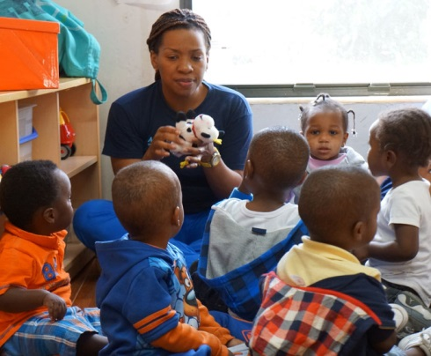
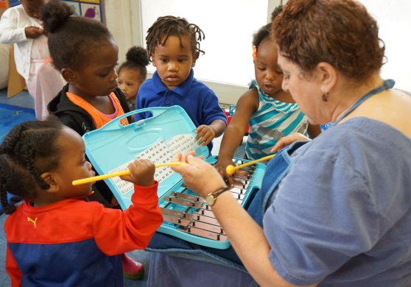

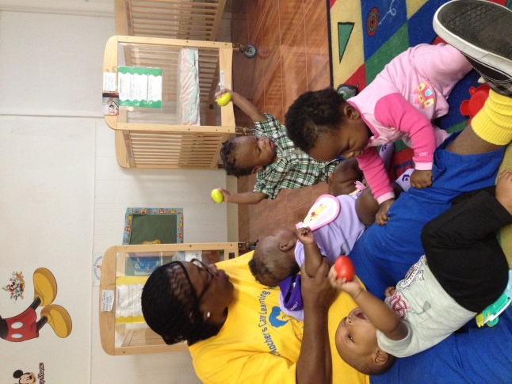

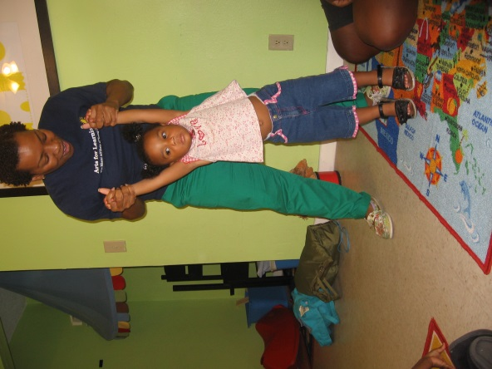

Baby ArtPlay! Family Program cultivates developmentally appropriate performing arts strategies for parent and their children. Developmental skills: intellectual/physical & social/emotional growth.

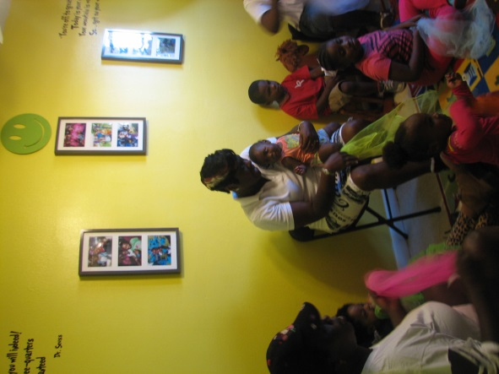
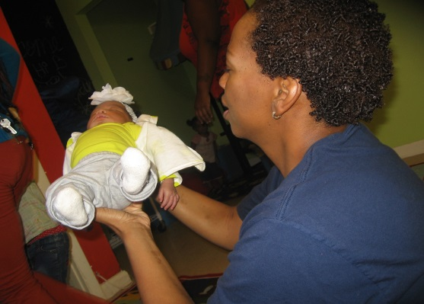

Parents Engaging Parents Sessions Spark Community Involvement in Liberty City

Published Monday, May 04, 2015
Trenika Raiford never imagined herself as a group facilitator, but motivated to help her Liberty City community she decided to step up.
Raiford, a single mom with three children who has lived all her life in the neighborhood, got a dose of training from Catalyst Miami – enough to provide her with basic skills and the spark of confidence to say: “Yes, I can.” She teamed with co-facilitator David Pickney, a father of four who was also born and raised in Liberty City, to facilitate a parents’ group that met over eight consecutive weeks at Shining Light Childcare Development Center.
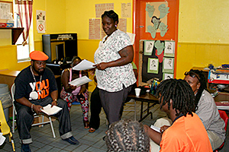

Co-facilitator Raiford guides the conversation with participants.
The parent group, associated with the Miami Children’s Initiative, and three others that were hosted respectively by Concerned African Women, Sant-La Haitian Neighborhood Center, and the Fatherhood Task Force of South Florida, met through the Parent Engagement Initiative, sponsored jointly by The Children’s Trust, The Children’s Movement of Florida, and the University of Miami. Catalyst Miami provided a 2-3 hour training with observation and coaching for between 15-17 facilitators.
“The study circles are very grassroots – they don’t require formalized facilitation. These groups come together because they have identified an issue or need in their community, and they are making something happen on their own,” explained Carolyn Nelson-Goedert, vice president of Community Leadership at Catalyst Miami.
“Facilitators don’t need to be subject-area experts. They just need some tools and some language that will help them guide because as facilitators their main job is to act as guides. Even though they say they haven’t led anything, as a parent they’ve already displayed some leadership skills. The training isn’t meant to be in-depth – it’s geared to help the parents feel prepared,” Nelson-Goedert explained.
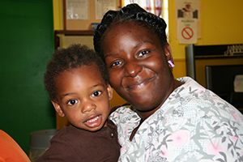

Trenika Raiford with one of the children at Shining Light Childcare.
Raiford, an early childhood educator for the past five years, emphasized that her role was simply to guide the conversation. “We’re not supposed to give information – we just listen and let their voices be heard,” explained Raiford, adding, “I love the chance to give back to the community by helping let parents share their experience.”
She made flyers and posted notices, but was nervous that not enough parents would show up. But show up they did. And they kept coming.
“I have two boys and I want to help them grow up in a positive neighborhood. The classes have helped me help my sons go right on the path of life,” said Kevin Frazier, who attended each of the eight sessions.
Zetreia Brown, mother of three children – four, three, and 11 months, saw a flyer about the parent meeting. She attended the first meeting and returned each week.
“It’s helped to hear that I’m not the only one with concerns. I have two teens at home, too, and the classes helped me find a different way to talk to them, especially my oldest son, I want him to know that I do trust his decisions, and that, out of love, I want the best for him.”
Brown said she would “absolutely” attend another session if offered. “It’s nice to know people are here to help," she said.
The parent group met once a week from 5:45 to 8 p.m. for eight weeks. They met, talked and shared dinner together.
Pinkney, with his own special energy as a co-facilitator, said the sessions helped break down walls. “Martin Luther King Jr. and Malcolm did their job – now it’s our turn,” he continued. “The parents have been so insightful, and some elders showing us what we want to know: how to break the cycle,” said Pickney, a father of four who said he is happily married.
Pickney confided that he was booted out of school when he was younger, that he was then one of “those” troubled youth. “School was conformity for me. I had to learn to think past that, to see the consequences. Now I have to open my mouth to share what I’ve learned,” he said. Pickney’s willingness to tell his own story helped build trust within the group so that others felt comfortable to talk.
Alyssa Zirkman, a UM student, attended the sessions at Shining Light as an observer.
“I was impressed with how quickly the parents moved to take action,” said Zirkman. “The outline called for a lot of brainstorming, but at the very first session the conversation moved right to violence as the key issue. They said: We see it every day, and this is what we’re going to do. The parents really honed in on that.”
Zirkman said listening to the parents really moved her. “I was just observing and taking notes and then I’d tear up every so often as someone would share about what happened in the news, how someone in their family had been affected.
“Everyone who came had experienced the violence. It was very heartwarming – there was so much sharing and love – and some of the parents had never even met before. There was so much sharing and love,” said Zirkman, who plans to write her thesis work based on her observations.
Renita Holmes, a well-known and long-time advocate in the area, attended the sessions, too. “We’re trying to get rid of this violence, to take action and hoping that something bigger comes out of it. We want to get to these kids so they don’t make the mistakes we made,” Holmes said.
As a result of the sessions, the Shining Light group coordinated a “Break the Cycle” community rally that took place recently at Arcola Lakes Park nearby the center.
With support from the Miami Children’s Initiative, a new round of meetings are planned.
“The same parents are excited to start again, and we want to bring some new ones out, too,” said Raiford, who’s eager to get the sessions going. “We hope to do something really big this time – we’d love to take the parents to Tallahassee to let their voices be heard.”

Article and photos by Michael R. Malone, The Children's Trust

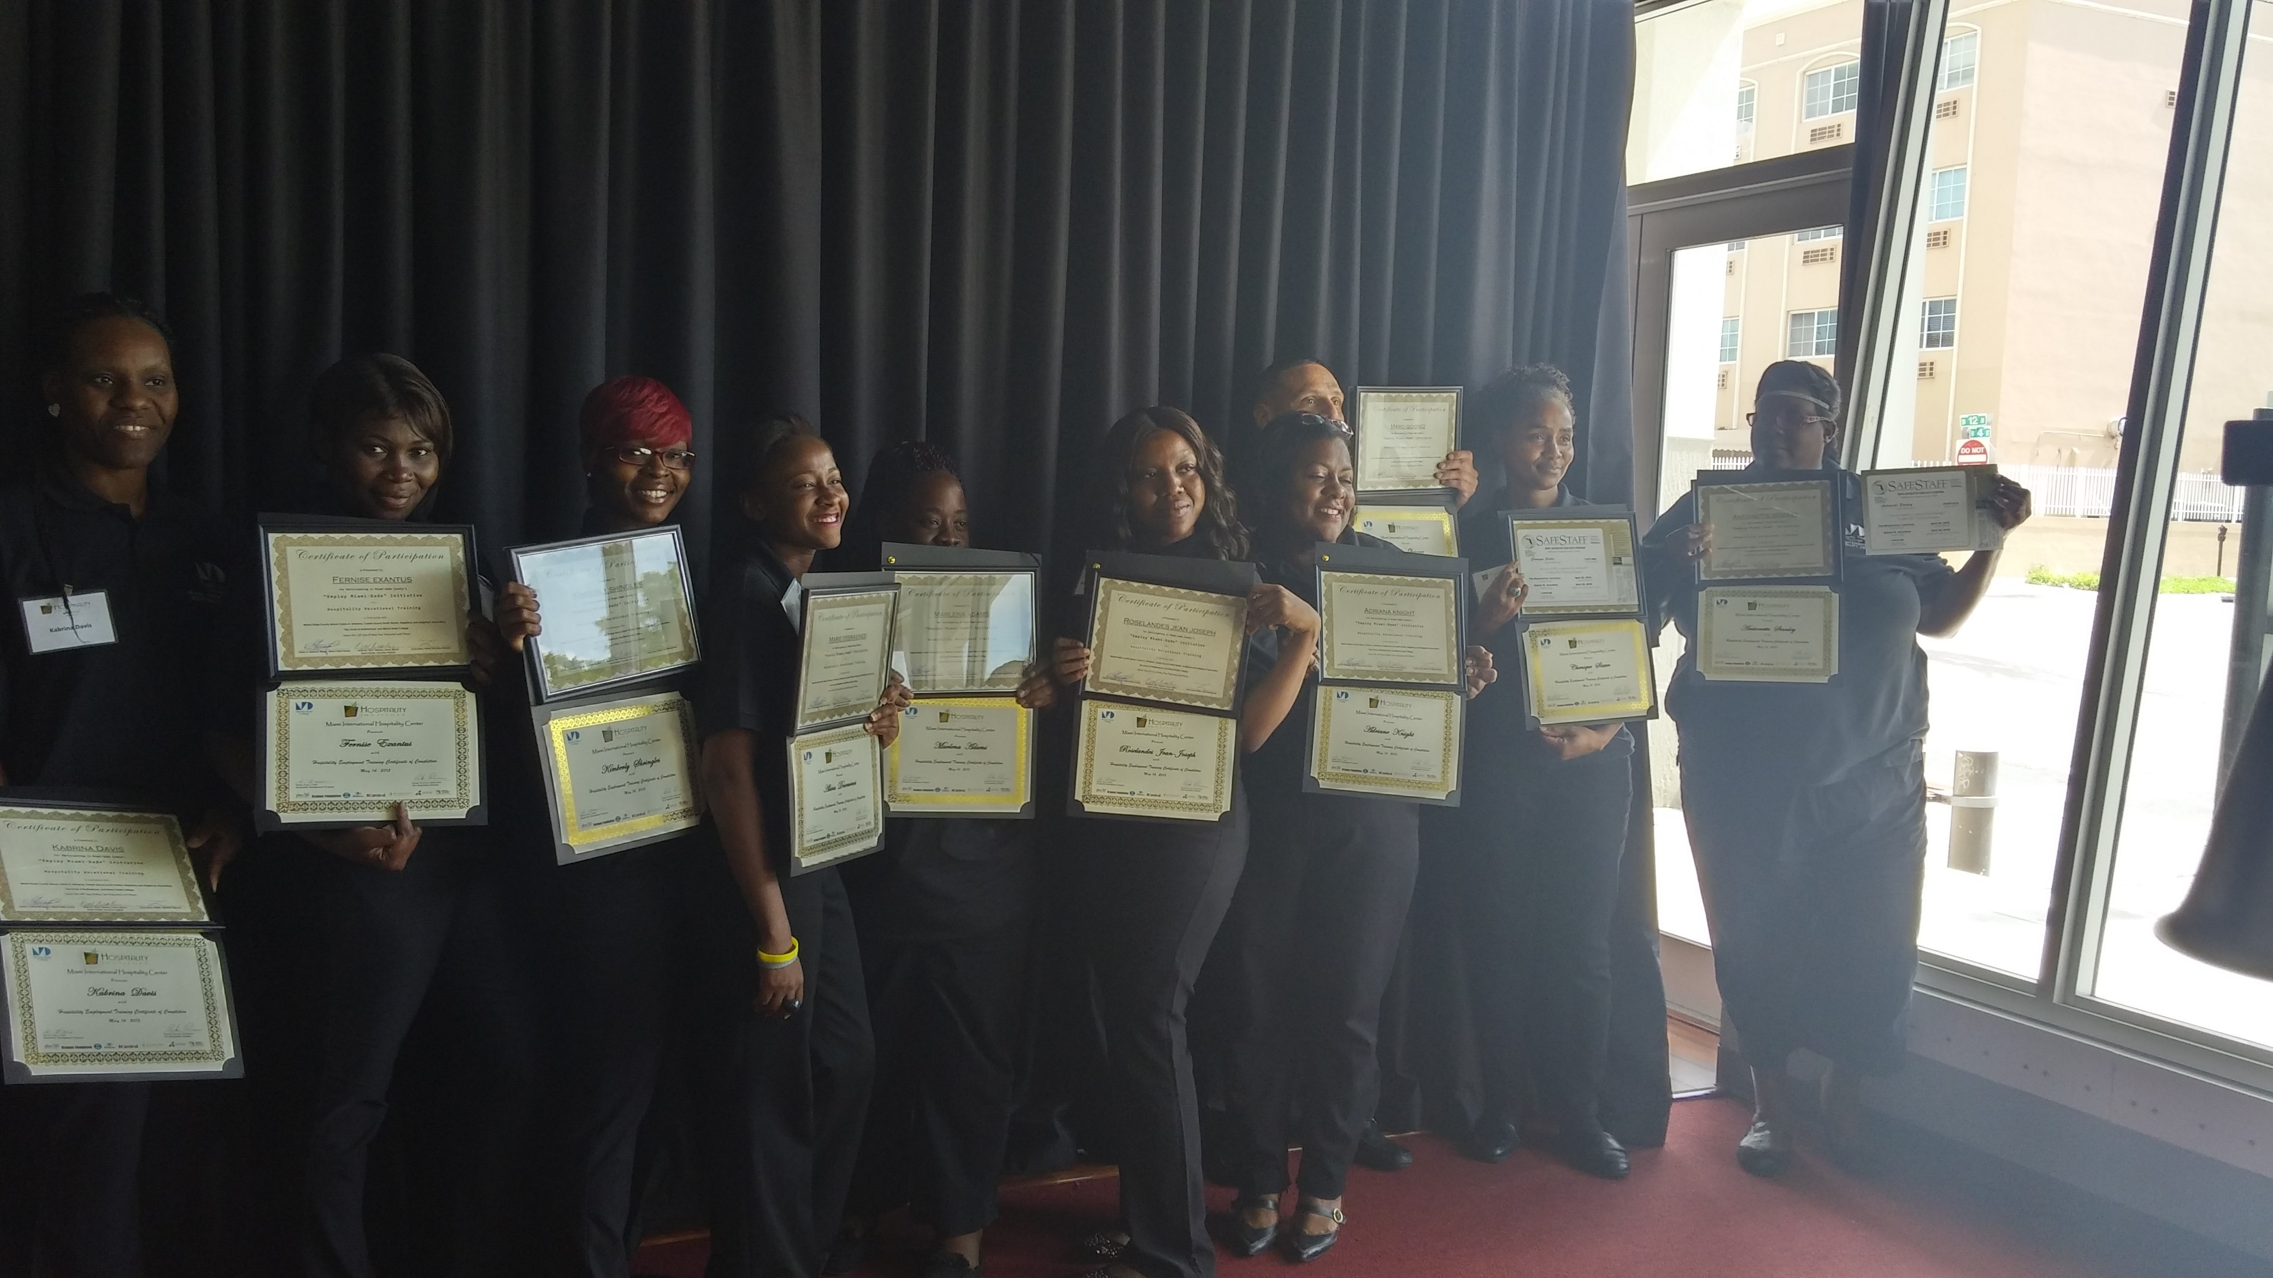

Employment assistance program graduates 2015

Summer Camp 2015
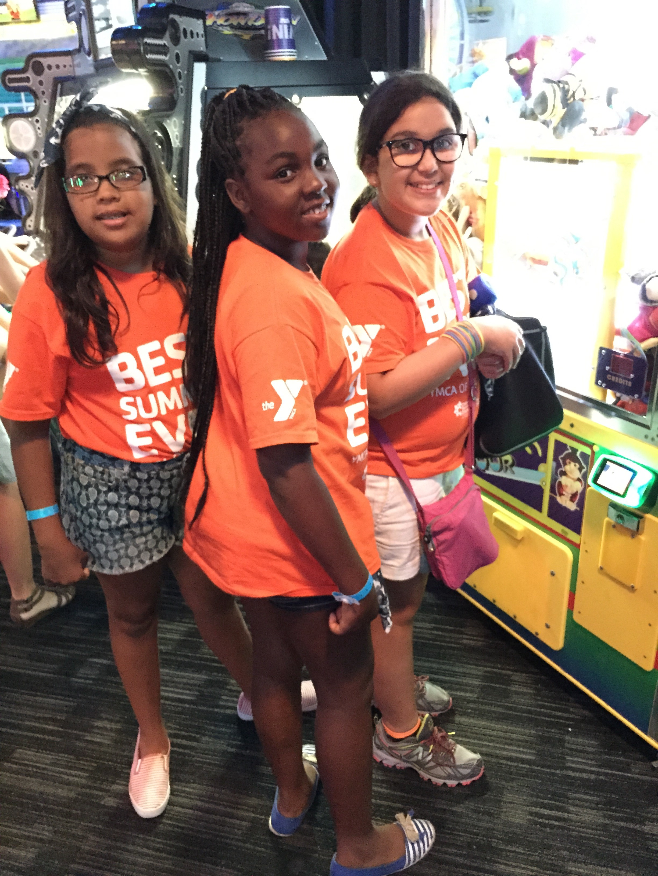Summer Camp 2015

One United Mural Project
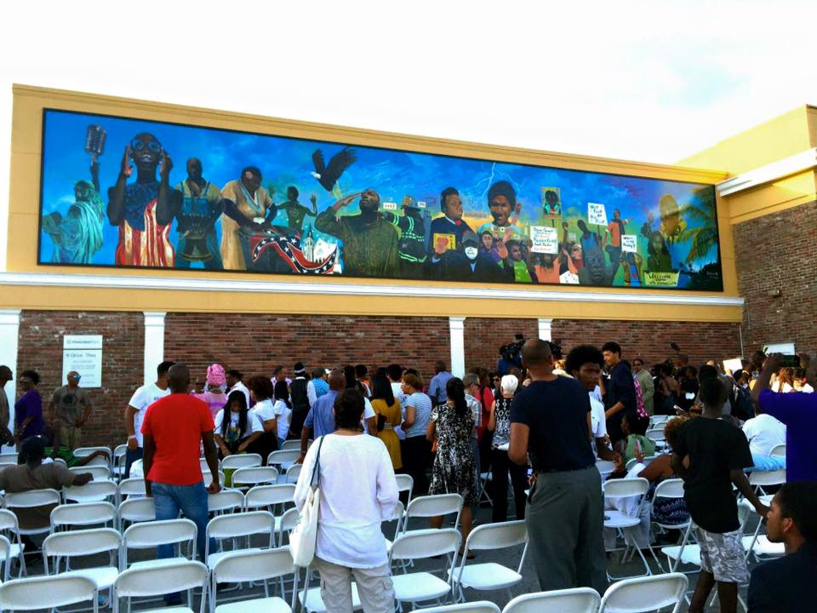

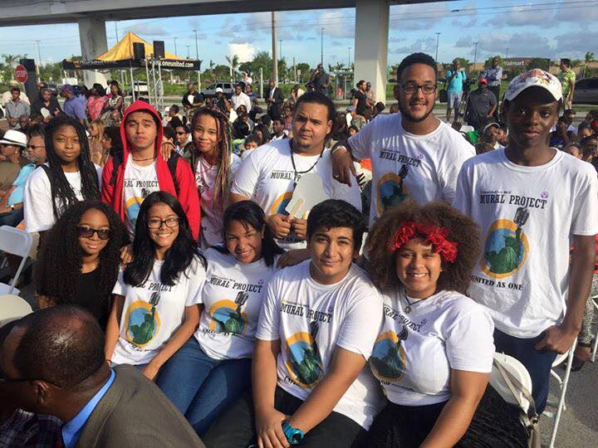

Harlem Children’s Zone Growth Plan FY 2001-FY 2009. http://www.huskysport.uconn.edu/huskysport/assets/file/HartfordZone/hcz/HCZ%20Business%20Plan.pdf

